4.4.8 Packet Tracer - Troubleshoot Inter-VLAN Routing
Addressing Table
Device | Interface | IP Address | Subnet Mask | Default Gateway | VLAN
R1 | G0/1.10 | 172.17.10.1 | 255.255.255.0 | N/A | VLAN 10
 | G0/1.30 | 172.17.30.1 | 255.255.255.0 | N/A | VLAN 30
PC1 | NIC | 172.17.10.10 | 255.255.255.0 | 172.17.10.1 | VLAN 10
PC3 | NIC | 172.17.30.10 | 255.255.255.0 | 172.17.30.1 | VLAN 30

Objectives
- Part 1: Locate Network Problems
- Part 2: Implement the Solution
- Part 3: Verify Network Connectivity

Scenario
In this activity, you will troubleshoot connectivity problems caused by improper configurations related to VLANs and inter-VLAN routing.

Instructions

Part 1: Locate the Network Problems
Examine the network and locate the source of any connectivity issues.

Commands you may find useful include:
R1# show ip interface brief
R1# show interface g0/1.10
R1# show interface g0/1.30
S1# show interface trunk

- Test connectivity and use the necessary show commands to verify configurations.
- Verify that all configured settings match the requirements shown in the Addressing Table.
- List all of the problems and possible solutions in the Documentation Table.

Documentation Table
Problems | Solutions
The PC3 default gateway is configured incorrectly  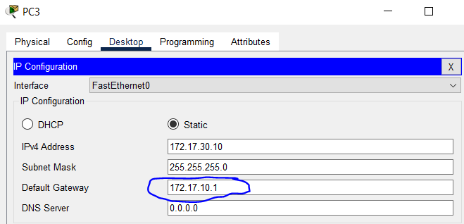 | Change the default gateway on PC3 from 172.17.10.1 to 172.17.30.1
Interface G0/1 on S1 is configured as access instead of trunk  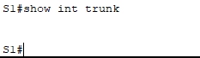  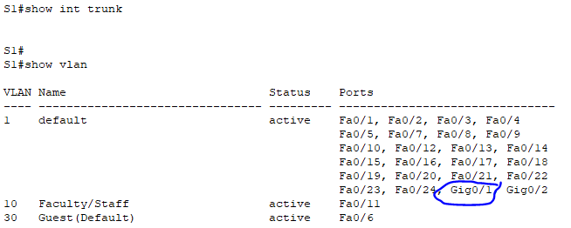 | Configure the interface G0/1 on S1 as a trunk use the “switchport mode trunk” command
Subinterface G0/1.10 is administratively down  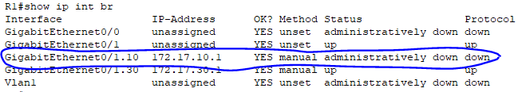 | Give the “no shutdown” command for the subinterface G0/1.10
Subinterface G0/1.10 is configured incorrect VLAN  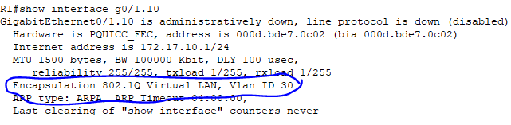 | Remove the incorrect Encapsulation dot1q, and assign the correct Encapsulation dot1q 10, then reassign the ip address for Subinterface G0/1.10.
Subinterface G0/1.30 is configured incorrect VLAN  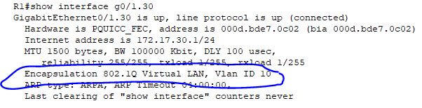 | Remove the incorrect Encapsulation dot1q, and assign the correct Encapsulation dot1q 30, then reassign the ip address for Subinterface G0/1.30

Part 2: Implement the Solutions
Implement your recommended solutions.

1) | Change the default gateway on PC3 from 172.17.10.1 to 172.17.30.1  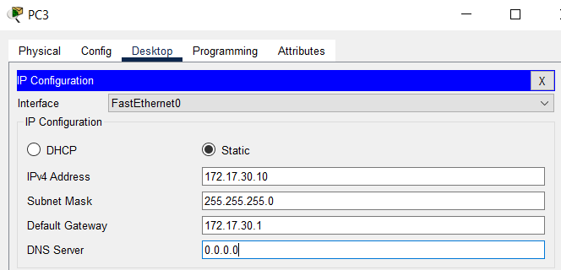
2) | Configure the interface G0/1 on S1 as a trunk use the “switchport mode trunk” command  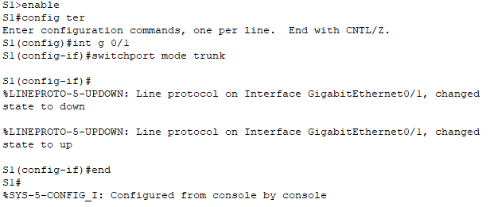  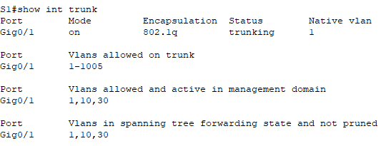
3) | Give the “no shutdown” command for the subinterface G0/1.10  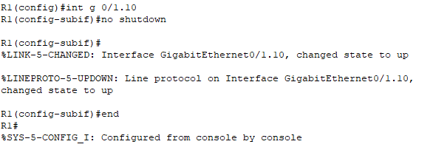
4) | Remove the incorrect Encapsulation dot1q, and assign the correct Encapsulation dot1q 10, then reassign the ip address for Subinterface G0/1.10  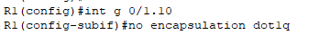  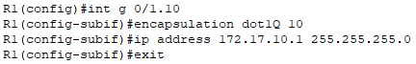
5) | Remove the incorrect Encapsulation dot1q, and assign the correct Encapsulation dot1q 30, then reassign the ip address for Subinterface G0/1.30  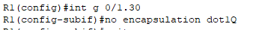  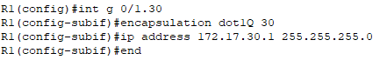

Part 3: Verify Network Connectivity
Verify the PCs can ping each other and R1. If not, continue to troubleshoot until the pings are successful.

PC1 ping PC3 | 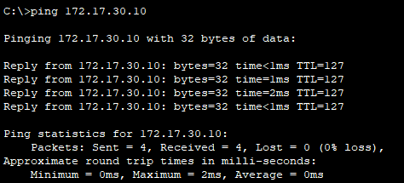
PC1 ping G0/1.10 on R1 | 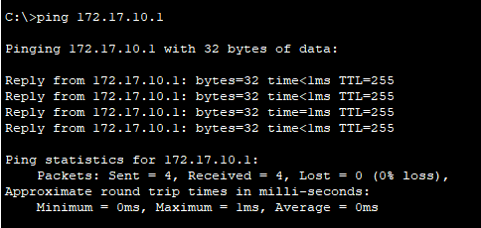
PC1 ping G0/1.30 on R1 | 